Customer Journey Map – Smart Sorting

This Customer Journey Map represents how users interact with the Smart Sorting system, from discovery to extended use. The journey is broken down into three main phases: Entice, Engage, and Extend. Each step reflects the goals, experiences, pain points, and opportunities associated with the use of the system.

|  |  |  |  |  |
| --- | --- | --- | --- | --- |
| Stage | User Action | Goals & Motivations | Pain Points | Opportunities |
| Entice | Learns about Smart Sorting via food tech news or demo video | Understand how to reduce food waste and improve sorting | Technical jargon, unclear benefits | Clear, visual demos and simple explanation |
| Engage | Uploads image of fruit/vegetable on the website | Detect freshness status in real-time | Low confidence in model prediction | Add confidence score and visual feedback |
| Extend | Uses feedback to avoid rotten items and reduce waste | Manage food inventory better | Doesn’t know how to act on alerts | Push notification with actions (e.g., 'Consume today') |

# Smart Sorting Roadmap :

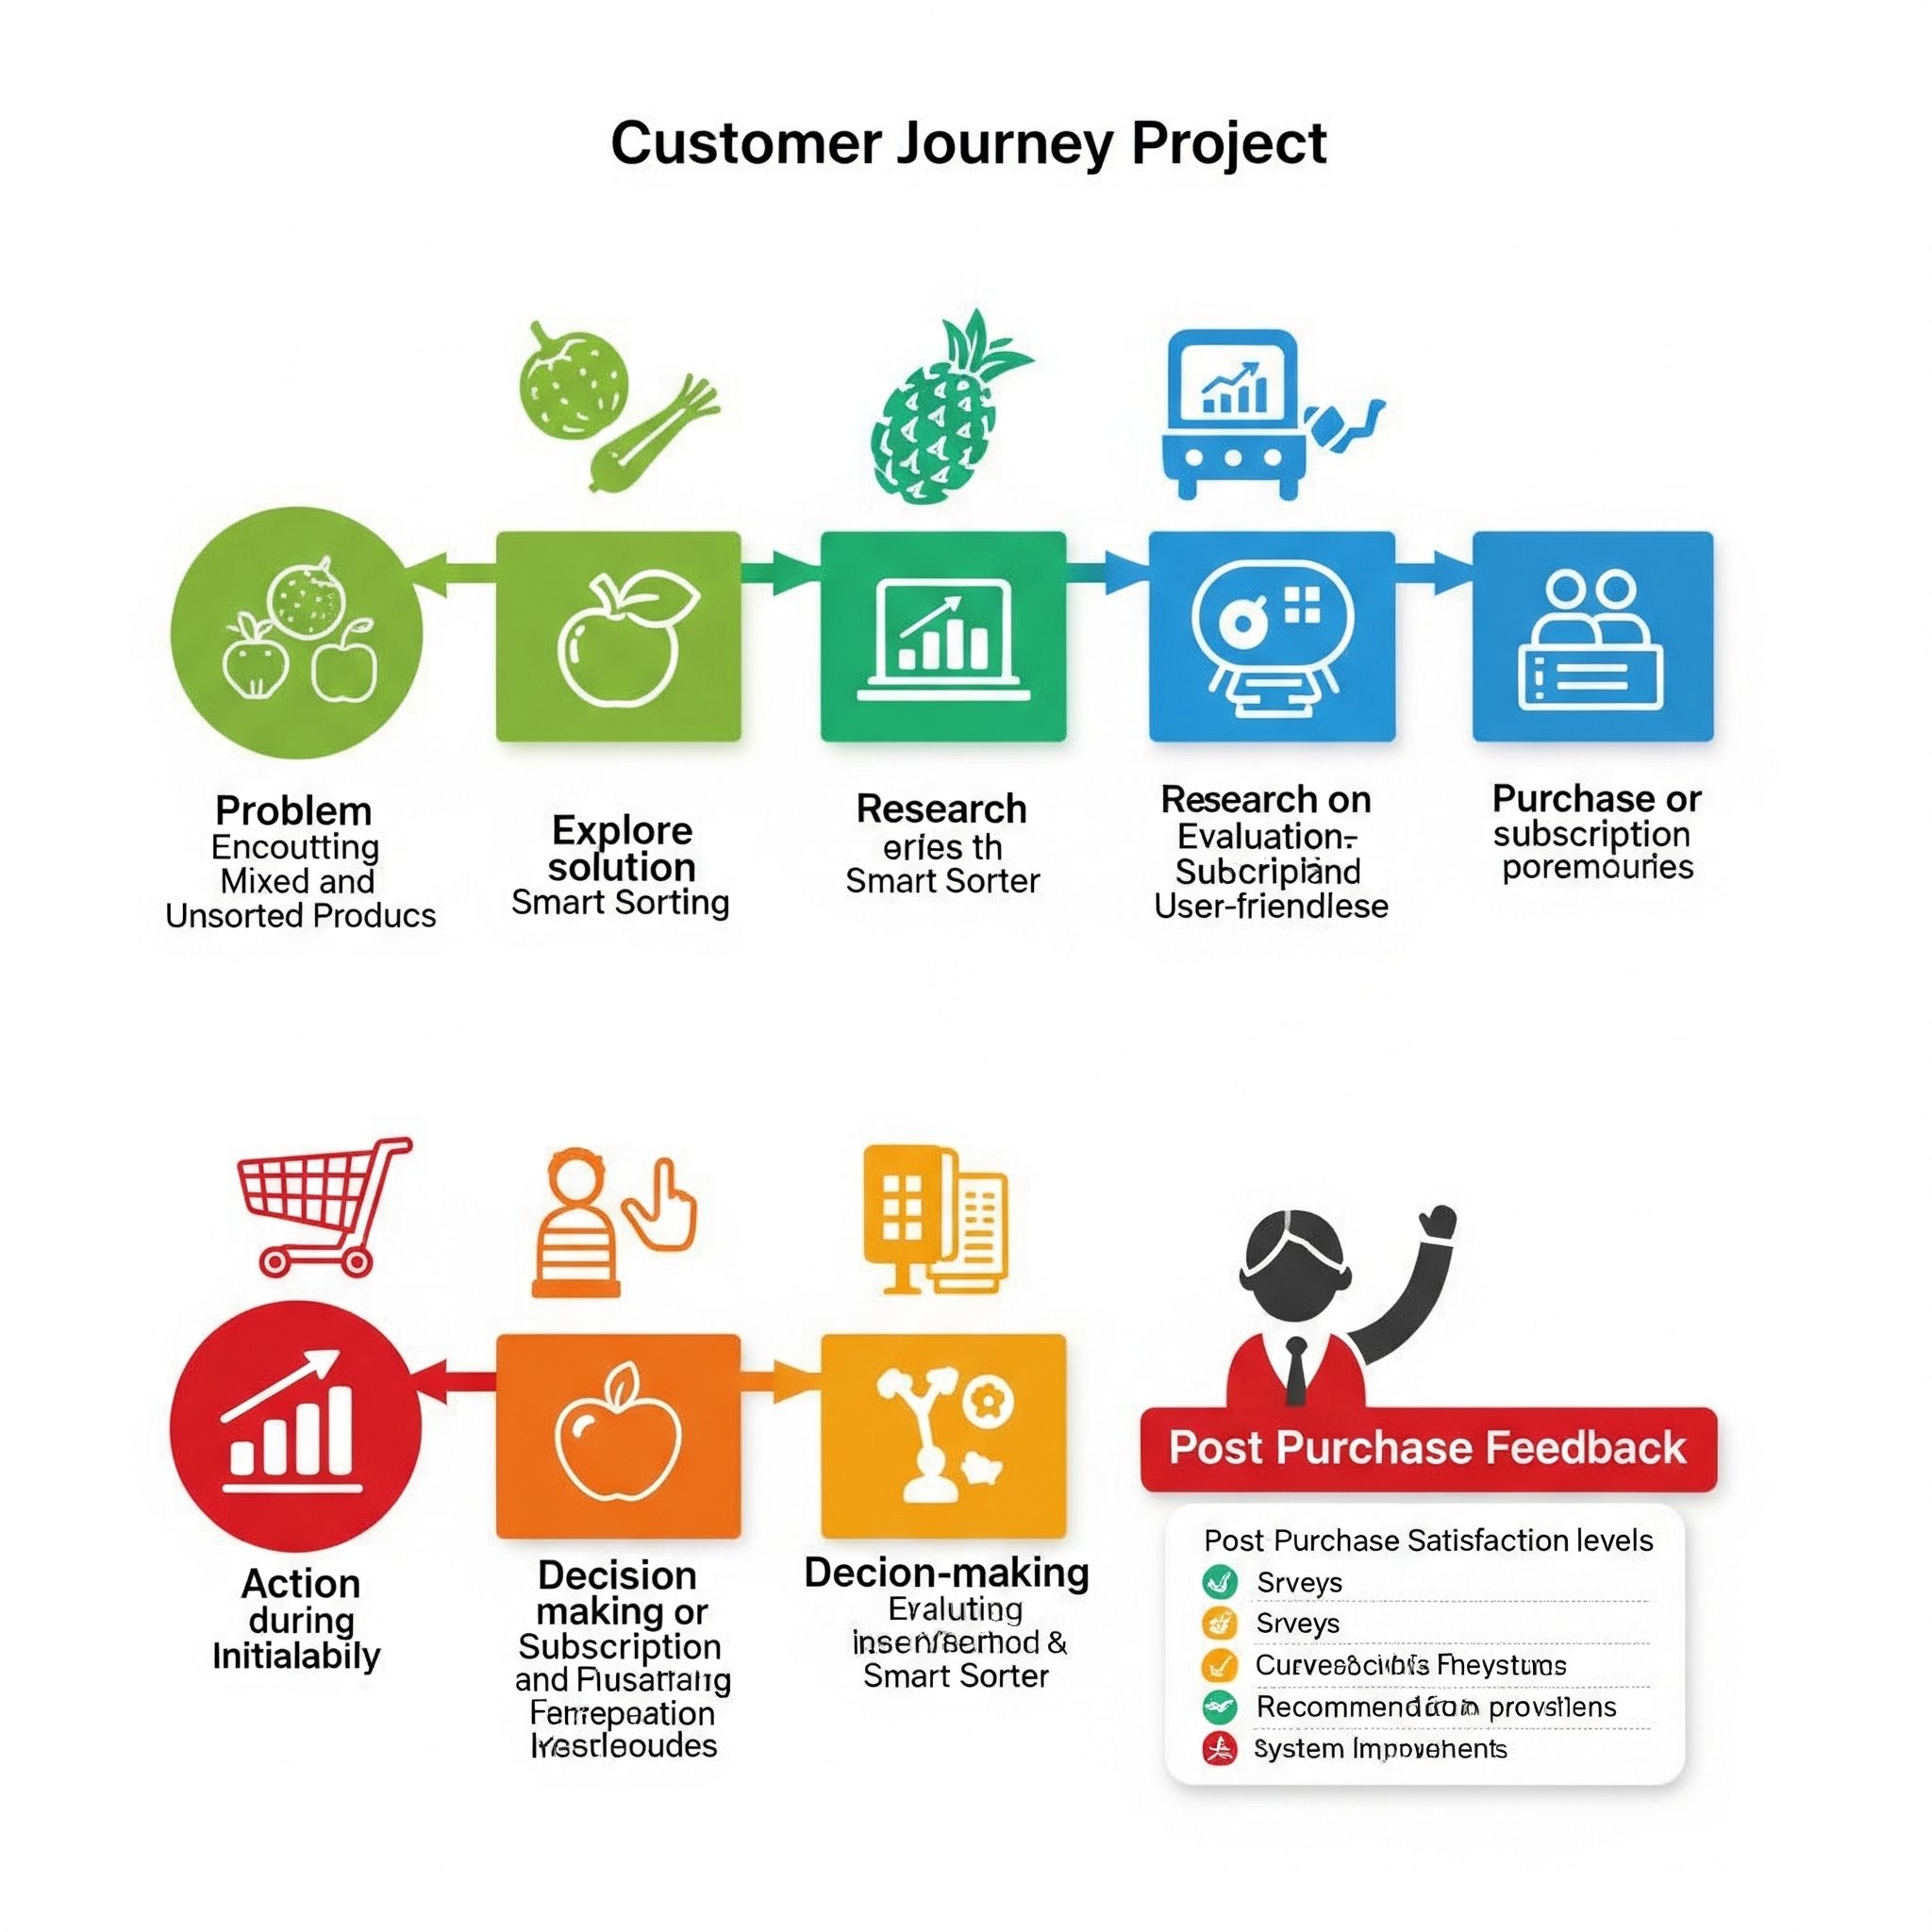

Figure: Simplified roadmap of the Smart Sorting user journey